**Python Assignment Question**

Write a Python program under Ubuntu operating system that extracts a zip archive of text documents and read their contents. Each text document contains a list of names. It displays the results on the screen and also writes a new file (output.txt), which contains a list of names that appear in every document.

An example zip (namelists.zip) archive is provided below, as well as example output.

namelists.zip

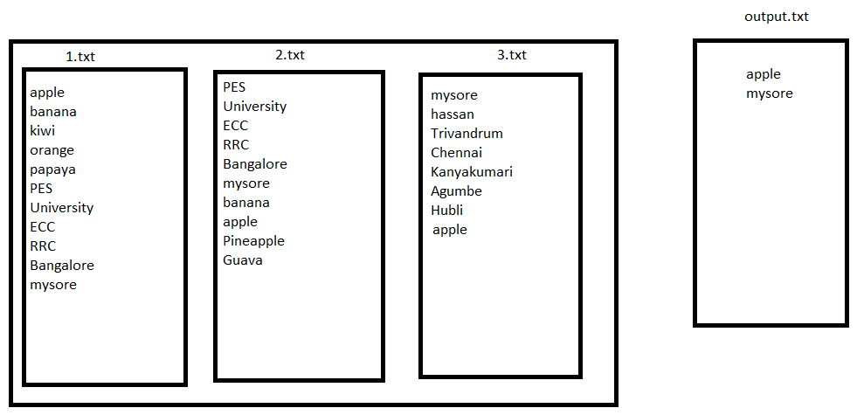

Also,

Write Python code that accepts a zip file as a command line and you donot know the names of the text documents in the zip file. The zip archive (namelists.zip) is just an example. Your script must work with a zip with any number of text files with any number of names in each. Order does not matter in your program's output.